Chemical physics is a highly interdisciplinary field at the intersection of physics and chemistry, focusing on understanding chemical processes and phenomena from a physical point of view. It uses principles and techniques from atomic, molecular, and condensed matter physics—such as quantum mechanics and statistical mechanics—to investigate the detailed physical properties and behavior of atoms, molecules, and chemical systems.

Microwave Spectroscopy
Microwave spectroscopy is a highly specialized and powerful technique within chemical physics at UTRGV, focusing on the study of rotational transitions in gas-phase molecules. This method probes the interaction between molecules and electromagnetic radiation in the microwave region, which corresponds precisely to the energy needed to induce transitions between quantized rotational energy levels.
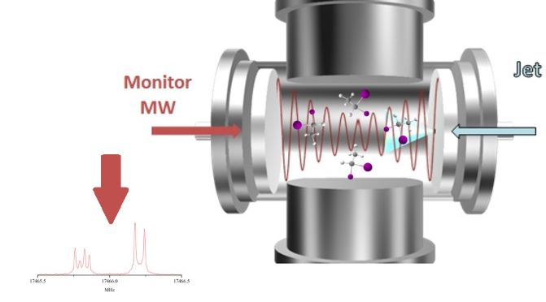
Key research areas utilizing microwave spectroscopy include:
- Precise Molecular Structure Determination: The rotational frequency is directly related to the moment of inertia of the molecule, which is defined by the masses of the atoms and their precise positions. By measuring the rotational constants from the spectral lines, researchers can determine highly accurate bond lengths and bond angles.
- Isotopic Analysis: Since the mass of an atom affects the moment of inertia, microwave spectroscopy can easily distinguish between molecules containing different isotopes.
- Identification of Astrophysical Molecules: Microwave spectroscopy is crucial for identifying molecules in space. The precise rotational frequencies measured in the lab serve as a spectral fingerprint to match against radio astronomical observations of interstellar clouds and circumstellar envelopes.

Research Faculty: Dr. Wei Lin

